Ornate Plasterwork Requirements?

Dunbar Plastering provide and install all bespoke decorative plasterwork, offer a full restoration and refurbishment service to enhance the beauty of your building.
Whether you are renovating with traditional materials such as lath & horse hair, “running in-situ with templated moulds”, lime plastering, using elegant fibrous plaster cornice, arches, ceiling roses, columns or pilasters, Dunbar Plastering are the dedicated service providers.

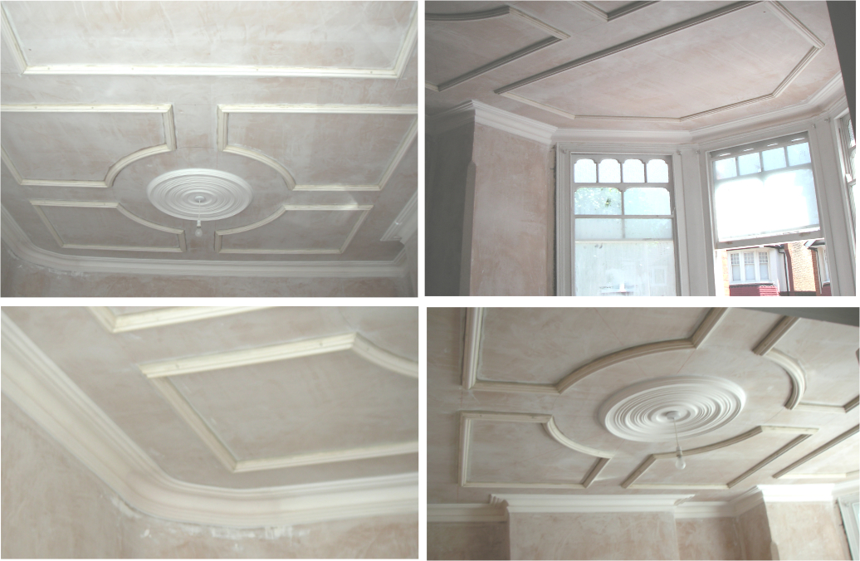
Please call Rob to discuss your requirements.
07711709869
dunbarltd@yahoo.co.uk

